**ONLINE ENTERTAINMENT**

Online social entertainment blends entertaining interactive functionality and content including live video streaming, multi-player gaming, music and videos streaming, with social networking. It is the foundation for a more immersive, interactive, enriching and engaging content consumption experience through social channels. Social entertainment is distinct from social networking websites in that the former is based fundamentally on immersive engaging experiences with functionality, content and people, while the latter is based primarily on building and maintaining relationships with other users.

**TYPES OF ONLINE ENETERTAINMENT**

1. 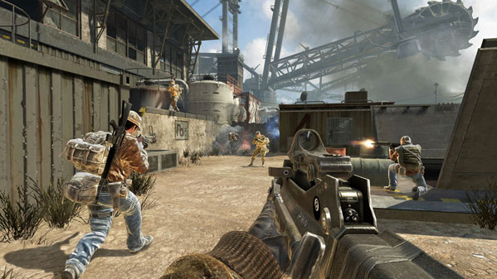**Multi-user games:** this is a video game in which more than one person can play in the same game environment at the same time. Many video games have single player activities pitting the player against preprogrammed challenges (which lack the flexibility of human thought).

**Advantages**

* Children get the chance to interact with others around the world
* multiplayer games will also contribute in boosting one’s self confidence since this is the type of gaming not only limited for forming groups or teams but as well as developing competition within each player. It encourages them to do better as reward points are given individually.
* These games permits competition, this will improve a player’s social interaction capacity as it allows supervision of co-players activity, resources and skills.
* Multiplayer games also promises a very exciting game experience since you are now dealing with other individuals unlike a typical one-player games

**Disadvantages**

* Many games are aimed for single player and so could be criticized for isolating you from your family and friends for many hours.
* Lack of being active and getting into outdoor activities e.g. sports
* The hardware and software itself can be very expensive, which can be a challenge when balancing what you want to spend your money on.
* A continuous use of thumbs and wrists and the straining of eyes which can lead to RSI and other physical problems.

1. **Video streaming:** Streaming media is multimedia that is constantly received by and presented to an end-user while being delivered by a provider. A client media player can begin to play the data (such as a movie) before the entire file has been transmitted. Distinguishing delivery method from the media distributed applies specifically to telecommunications networks, as most of the delivery systems are either inherently streaming (e.g., radio, television) or inherently non streaming (e.g., books, video)

**Advantages**

* With downloads the files has been stored locally and so you can use it of-line.
* There are plenty of legitimate sites where you can get safe downloads- music, apps film
* It is possible to download legitimate music files that do not include DRM and so makes it easier for you to listen to your tracks on different devices.

**Disadvantages**

* FTP client can be awkward to use but it can handle part downloads
* You need a reasonable connection speed in order to download in practical length of time –especially films and t.v programs
* There is a threat for the download of viruses.
* If your computer breaks down or the hard disk fails then you may lose the software you have bought because you do not have a CD to re-install.

1. **Social networking**

This is a platform to build social networks among people who share similar interest, activities, backgrounds or real life connections. A social network sites are web-based services that allow individuals to create a public profile and interact with others online. All one needs is to create an account with an email address and password.

Advantages

* No matter where you are or your friend or family member is you will still be able to communicate with them through social networking networks.
* With these social networking site people are able to find common interests between them and others around the world.
* Many of these social networks have adopted an instant messaging feature which enables you to have a conversation in real time.
* For anyone trying to pass the word out about a fund raiser or an upcoming event there is no easier way than posting.

Disadvantages

* A big disadvantage of social networking is that face to face socialization is eliminated. Because of the autonomy afforded by the virtual world individuals are free to create a fantasy persona can pretend to be someone else.
* Recently cases of cyberbullying of children have raised and is becoming a one of the biggest threat to children around the world. Some extreme cases have led to children committing suicide and or self-harm
* You can never be very sure of the person you are talking to i.e. cases of identity theft.
* 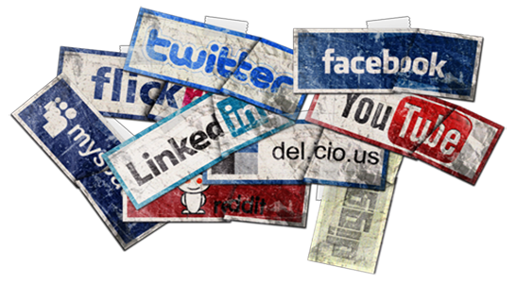Many people in work environments or any official field might spend too much time on social networks diverting their attention from work.